Advanced Engineering Ordering & Selling

Program PRODUCT & BUNDLES
HARDWARE: The Advanced Engineering hardware kit includes a TETRIX Advanced Engineering build kit with sensors from Pitsco and a myRIO controller from National Instruments. These kits can be purchased individually or added to orders including the bundle part numbers above to create non-standard part number scenarios. Bundle Part Number ADV-ENG-HWKIT.

SOFTWARE: LabVIEW Academic Site License is included with the program. LabVIEW can only be sold as part of the bundle; we have not received approval to sell LabVIEW as a standalone product. LabVIEW is offered as a High School 10 seat license or as a Site License for Technical and Community Colleges.

CURRICULUM: Two 90 hour semesters targeted at the 11th – 12th grade high School programs as “Advanced Engineering with myRIO” or 1st – 2nd year Post Secondary as an introduction to LabVIEW. Each Semester topic includes theory plus a mini-project to include hands on Project Based Learning. We will be shipping Semester I curriculum June 2015 and Semester II will be available November 2015. For customers that order now, we will ship equipment and curriculum starting June and semester II will be added in November once it becomes available.

- 77-8155-0010 – LM7 Content, Lab, Advanced Engineering Semester I
- 77-8155-0020 - LM7 Content, Lab, Advanced Engineering Semester II

Semester I content prepares students for the Certified LabVIEW Associate Developer (CLAD) assessment.

Semester II includes advanced LabVIEW programming integrated with project based system design using a mobile labyrinth maze as the arena for each design project.

Semester I Content Outline
- What is LabVIEW
- Troubleshooting & Debugging
- Introduction to VI’s
- Developing Modular Applications
- Organizing Data
- File I/O
- Using Variables
- Common Design Techniques
- Synchronization Techniques
- User Control
- Error Handling
- Controlling the User Interface

Semester II Content Outline
- Introduction to myRIO
- Dead Reckoning
- Introduction to Sensors
- Filtering Data
- Wireless Controls & Dashboard
- P.I.D.
- Advanced P.I.D.
- Computer Vision
- 3 Axis Stabilization
- Capstone Project
Bundle Part Numbers:
- ADV-ENG-HS10 – 10 student bundle includes 6 kits, Semester 1 and Semester 2 of Advanced Engineering curriculum and the option to include a 10 seat LabVIEW License – HIGH SCHOOL ONLY
- ADV-ENG-PS10 – 10 student bundle includes 6 kits, Semester 1 and Semester 2 of Advanced Engineering curriculum and a 10 seat license of LabVIEW – POST SECONDARY ONLY
- ADV-ENG-PS20 – 20 student bundle includes 11 kits, Semester 1 and Semester 2 of Advanced Engineering curriculum and the option to include an academic site license of LabVIEW – POST SECONDARY ONLY

WARRANTY: Included 1 year limited warranty on hardware only. Software media is warranted for 90 days. ALL WARRANTY & SUPPORT CLAIMS ARE PROCESSED THROUGH INTELITEK TECHNICAL SUPPORT TEAM.
myRIO Warranty - National Instruments warrants its hardware products against defects in materials and workmanship for a period of one (1) year from the date it is shipped to the customer. In the event a reseller purchases a product from NI, integrates it with a system, and sells it to a user, the warranty period still begins on the original ship date from NI. This limited warranty is void if the product's failure has resulted from accident, abuse, misapplication, modification, improper calibration by the customer, use of an improper hardware or software key, or unauthorized maintenance or repair. Hazards such as lightning, flood, exceeding voltage specifications, or customer abuse are not covered under warranty.
LabVIEW - The media on which you receive National Instruments software are warranted not to fail to execute programming instructions, due to defects in materials and workmanship, for a period of 90 days from date of shipment, as evidenced by receipts or other documentation. National Instruments will, at its option, repair or replace software media that do not execute programming instructions if National Instruments receives notice of such defects during the warranty period. National Instruments does not warrant that the operation of the software shall be uninterrupted or error free.
The full LabVIEW software license agreement can be found here:
http://www.ni.com/pdf/legal/us/software_license_agreement.pdf

Pitsco Kits – Pitsco warrants all products for one year from the date of purchase provided the product has not been misued, abused or used inappropriately.

PRICING
- Advanced Engineering kits will be sold in 10 or 20 student bundles which include 6 or 11 hardware kits respectively, LabVIEW software, Semester 1 and Semester 2 curriculum.
- The High School 10 student bundle and Post Secondary 20 student bundle includes an option with LabVIEW removed.
- TETRIX Prime Hardware kits including the myRIO controller can be ordered individually or added to existing bundles.

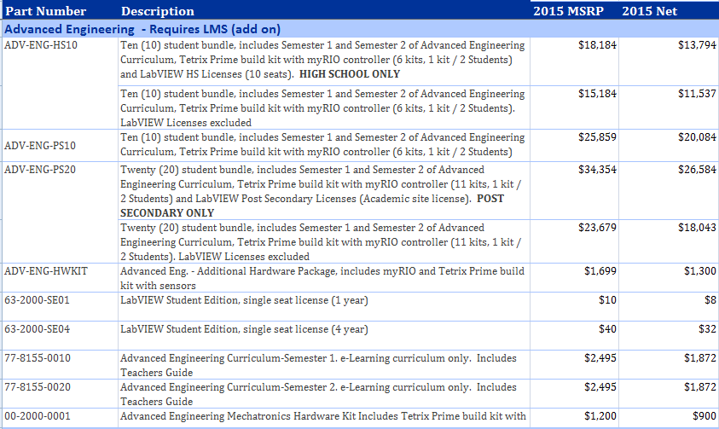
Options for schools with LabVIEW software
Schools may have a LabVIEW k12 Education license. This is an educational version of LabVIEW software and does not include the add-on modules required to communicate or operate the myRIO. The following LabVIEW software and add-on modules are required.
- LabVIEW K12 Education Edition (2014)
- NI myRIO Software Suite
- LabVIEW Real-Time Module
If a school owns a copy of LabVIEW, the school will need to verify the LabVIEW Real-Time plug-in and the FPGA module are included with their existing version.
The NI myRIO software suite contains drivers needed for the myRIO and is available at no cost to end users. The LabVIEW Real-Time Module allows LabVIEW to download user created VI’s to the myRIO and is available to purchase at $672.50 each computer. The school would need to purchase this from NI or authorized reseller and is not available from Intelitek.
The Intelitek bundles include LabVIEW Academic Premium Suite software licenses and contain all the necessary add-ons to operate the myRIO as part of the bundle.
LabVIEW options from Intelitek.

- LabVIEW Premium Suite 10 seat License (High School Only) - $3000
- LabVIEW Academic Site License (Available Post Secondary only) A site license covers one academic department for up to 50 computers. $10,675
- 63-2000-SE04 - LabVIEW Student Edition – (4 year perpetual license) – Students Only $40.00 each
- 63-2000-SE01 - LabVIEW Student Edition – (1 year annual license) – Students Only $10.00 Each

Selling territories
NI Products: myRIO and LabVIEW
USA & CANADA: Intelitek is allowed to distribute myRIO & LabVIEW in the US and Canada as part of the Advanced Engineering program. The myRIO or LabVIEW cannot be sold as an individual product and must be included with the Advanced Engineering program. You can add additional myRIOs to the program by ordering the Hardware Kit.
REST OF WORLD: if there are opportunities to sell in ANY OTHER TERRITORY outside of the USA, we can ‘register the deal’ with NI (we have successfully done so). In order to register a deal: send an email to Trevor Pope with the subject “Advanced Engineering in Territory” with Territory being the country of the potential sale. Include the following information.
- Customer Contact Name:
- Customer Complete Address:
- Number of Advanced Engineering Programs you are Quoting:
- Quantity of myRIOs and LabVIEW licenses:
- Expected date for the deal to close:
Alternately, if the customer has a distributor that they can obtain the NI parts from in their country – you can sell the curriculum and TETRIX kits and the customer can obtain the myRIO and LabVIEW from their own sources.
NI Training: LabVIEW Academy
LabVIEW academy can be sold throughout the US and Canada. As soon as it is available in self-paced format (English) it can be sold globally.

ORDERING & DELIVERy EXPECTATIONS
The Advanced Engineering Kits & LabVIEW will be stocked and shipped from the Intelitek warehouse. We will begin shipping Semester I kits and curriculum in June 2015. Semester II curriculum will ship in November & remain on backlog until them.

SUPPORT FOR SALES DEALERS
The product is listed on the Intelitek website http://www.intelitek.com/engineering/advanced-engineering/
There is also a brochure available for download: http://www.intelitek.com/pdf/35-1010-0008-B_Advanced-Engineering.pdf

The brochure and Website noted above with be updated with additional information. A pre-recorded webinar presented together with NI is available in the dealer zone section of the Intelitek webpage. http://www.intelitek.com/dealers/
NI Certified LabVIEW Associate Developer (CLAD) Certification
The NI Certified LabVIEW Associate Developer is the first step in the three-part NI LabVIEW certification process. It indicated a broad working knowledge of the LabVIEW environment, a basic understanding of coding and documentation best practices, and the ability to read and interpret code. It is the entry-level LabVIEW certification and is valid for 2 years from the date taken. The certification is a multiple choice assessment that lasts one hour and must be taken at a Pearson VUE testing center or NH Branch office. There are no prerequisites.
If an instructor is CLAD Certified they can administer the CLAD Exam at their facility.

Finally, we are working on a one day ‘sales’ workshop to be delivered in LearnMate 7 and be used to walk individuals though the curriculum and the benefits of such. This is a ‘pre-sales’ workshop and not training.

SUPPORT FOR END USERS
Intelitek support will handle all service issues regarding the Advanced Engineering program. If there is a problem that can’t be solved directly or of a product needs to be returned the Intelitek representative will refer the customer to the appropriate vendor.
For National Instruments support the Intelitek rep will:
- Go to www.NI.com/support
- Select ‘Contact an Engineer’
- Create a NI profile and open a new service request
- Provide customer the SR#
The end user will:
- Call RMA support (800) 433-3488 and reference SR#
- Customer is routed to AE for troubleshooting

Professional Development
Intelitek will offer a 4 day summer training to teach LabVIEW with specific intent to support teachers of the new Advanced Engineering program from July 28-31, 2015. We strongly encourage dealers to include this in each Advanced Engineering quotation. Check out the whole week training which includes LearnMate for Teachers or just the LabVIEW Academy session.
- PDT-WKSP-WEEK4 – Week 4 Summer Workshop Training; Full Week
- 50-0001-0ENG – Professional Development – LabVIEW Academy

In addition, Intelitek is an authorized reseller of LabVIEW Academy. This is a course developed by National Instruments to learn LabVIEW and is highly recommended for teachers who are not familiar with LabVIEW software or programming. Very soon, we will be able to offer this program on-line in a self paced environment.
- 50-0004-0SPC – Professional Development – LabVIEW Academy – Self Paced

